1. **Write a Python program to print yesterday, today, tomorrow.**

import datetime as dt

today=dt.date.today()

yesterday=today-dt.timedelta(1)

tomorrow=today+dt.timedelta(1)

print('Today:-',today)

print('Yesterday:-',yesterday)

print('Tomorrow:-',tomorrow)

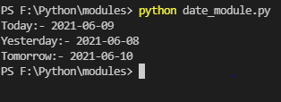

1. **Write a Python program to print next n days starting from today.**

import datetime as dt

from time import strftime

x=dt.date.today()

n=int(input('Enter number of days from today='))

for i in range(0,n):

day=x+dt.timedelta(i)

print(day,day.strftime('%A'))

